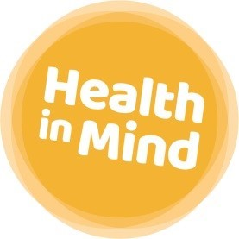
Terms and Conditions
The following terms and conditions are offered by Health in Mind.
Holiday Entitlement:
30 days annual leave, 2 wellbeing days plus 10 public holidays full time (36.25 hours per week). Pro-rata for part-time staff.
Sick Pay:
In addition to Statutory Sick Pay (SSP), Health in Mind offer a generous company sick pay scheme that increases with your length of continuous service.
Length of Continuous Employment at the start of each absence | Full pay allowance | Half pay allowance
Less than 1 year | 5 weeks | 5 weeks
1 – 2 years | 9 weeks | 9 weeks
2 – 3 years | 18 weeks | 18 weeks
3 – 5 years | 22 weeks | 22 weeks
5 years or more | 26 weeks | 26 weeks

Pension:
Health in Mind uses the government NEST scheme and operates auto-enrolment into our pension scheme. You will be automatically enrolled into the scheme if you earn more than £10,000. Full information for employees is provided. The employer contribution is 3%.
Employee Assistance Programme:
Health in Mind offers a comprehensive Employee Assistance Programme through Legal and General. This offers a range of services including telephone support, legal information, medical information, structured telephone and face to face counselling, and Active Care (early intervention for stress).
Union:
Health in Mind has a recognition agreement with Unite the Union. All staff have the opportunity to join Unite.

General employment policies:
Heath in Mind is an equal opportunities employer and we are proud of our terms and conditions. We recognise that from time to time our employees may need additional support and as such we offer a flexible and supportive working environment. This includes specific policies on matters such as paid compassionate leave, special leave, financial support for occupational training and the opportunity to negotiate flexible working arrangements.

